
An Industry Oriented Mini Project Report
On
RAILWAY LEVEL CROSSING GATE CONTROL BY ANDROID APPLICATION
Submitted in partial fulfillment of the requirements
For the award of the degree
Of
BACHELOR OF TECHNOLOGY
in
ELECTRONICS & COMMUNICATION ENGINEERING
By
CH K CHAITANYA ( HT.NO:17831A0414)
K RAJA (HT.NO:17831A0435)
K SAITEJA (HT.NO:14781A0436)
Under the guidance of
Mr S Sivaiah
Assistant Professor

DEPARTMENT OF ELECTRONICS & COMMUNICATION ENGINEERING

GURU NANAK INSTITUTE OF TECHNOLOGY
(Approved by All India Council for Technical Education, New Delhi, NBA Accredited & Affiliated to JNTU Hyderabad)
Campus: Ibrahimpatnam, R.R. District 2020-2021

(Approved by All India Council for Technical Education, New Delhi, NBA accredited & Affiliated to JNTU Hyderabad) Campus: Ibrahimpatnam, R.R. District – 501506 (T.S.) Ph: (0/95) 8414-202120/21 Fax: 08414-223344 City Office: B2, 2nd floor, Above Bata, Vikrampuri Colony, Secunderabad – 500009, Ph: 040 – 66323294, 65176117 Fax: 040 – 27892633

CERTIFICATE
This is to certify that an Industry Oriented Major Project report entitled” RAILWAY LEVEL CROSSING GATE CONTROL BY ANDROID APPLICATION” is being submitted by CH K CHAITANYA ( HT.NO:17831A0414), K RAJA (HT.NO:17831A0435), K SAITEJA (HT.NO:14781A0436) in partial fulfillment for the award of Degree of Bachelor of Technology in ELECTRONICS AND COMMUNICATION ENGINEERING of Jawaharlal Nehru Technological University during the year 2020-2021. The project report has been approved as it satisfies the academic requirements in respect of project work prescribed for Bachelor Degree.

Internal guide: Project coordinator: Head of the Department:
Mr. S.Sivaiah Mrs.S.Vasanti Dr.B.Kedarnath
Asst.Professor Asst.Professor Professor
Department of ECE Department of ECE Department of ECE

Principal:
Dr.S.Sreenatha Reddy
GNIT

(Approved by All India Council for Technical Education, New Delhi, NBA accredited & Affiliated to JNTU Hyderabad) Campus: Ibrahimpatnam, R.R. District – 501506 (T.S.) Ph: (0/95) 8414-202120/21 Fax: 08414-223344 City Office: B2, 2nd floor, Above Bata, Vikrampuri Colony, Secunderabad – 500009, Ph: 040 – 66323294, 65176117 Fax: 040 – 27892633
DECLARATION
We, hereby certify that the work which is being presented in the thesis entitled “RAILWAY LEVEL CROSSING GATE CONTROL BY ANDROID APPLICATION”is being submitted by CH K CHAITANYA( HT.NO:17831A0414), K RAJA (HT.NO:17831A0435), K SAITEJA (HT.NO:14781A0436) in the partial fulfillment for the award of degree of Bachelor of Technology in the Department of ECE is an authentic record of our own work carried out during a period from December 2020 to February 2021.The matter presented in this thesis has not been submitted by us in any other University/Institute for the award of any Degree.
Signature of the Students
CH K CHAITANYA K RAJA K SAITEJA
This is certifying that the above statement made by the candidates is correct to the best of our knowledge.
Signature of Internal Guide
The B.Tech Viva-Voce Examination of CH K CHAITANYA ,K RAJA K SAITEJA has been held on _____________and it is accepted.
Signature of HOD

ACKNOWLEDGEMENT

An Industry Oriented Major Project entitled “RAILWAY LEVEL CROSSING GATE CONTROL BY ANDROID APPLICATION ” has seen the light of the day because the success of this project is attributed to the intensity, drive and technical competence of many individuals who contributed to make this project a reality despite all odds. So, we express heartfelt pleasure for the people who helped us in this project and gave a never ending support right from the stage the idea was conceived.
We deeply express our sincere thanks to Mr. S.Sivaiah, Asst.Professor Of Department of ECE and our Internal guide for his excellent guidance and constant encouragement throughout the project work. His timely advices and endless debates ensured the completion of project report in time.
We express our sincere thanks to Mrs.Vasanti, Project Coordinator and our entire faculty, without their constant encouragement and everlasting support this work would not have been possible.
We heartfully thank our Head of the Department Dr.B.Kedarnath for his excellent support to complete our project.
We cordially thank Dr. Anmol Goyal, Dean Academics for his valuable guidance.
We would like to express my profound sense of gratitude to Dr. S. Sreenatha Reddy, Principal for his constant and valuable guidance.
We are deeply indebted to Honorable Dr. H. S. Saini, Managing Director of Guru Nanak Institutions, for constant Cooperation during the course of work.
Last but not least, we would like to thank all teaching and Non-teaching staff members of ECE department for their support and also, we would like to thank God for all good deeds.
In All Sincerity,
CH K CHAITANYA( HT.NO:17831A0414)
K RAJA (HT.NO:17831A0435)
K SAITEJA (HT.NO:14781A0436)

VISION AND MISSION OF INSTITUTE

Vision:

To be a World-class Educational and Research Institution in the service of humanity by promoting high quality Engineering and Management education.

Mission:
M1: Imbibe soft skills and technical skills.
M2: Develop the faculty to reach international standards.
M3: Maintain high academic standards and teaching quality that promote analytical thinking and Independent judgement.
M4: Promote research, innovation and product development in collaboration with reputable Foreign Universities.
M5: Offer collaborative industry program in the emerging areas and spirit of enterprise.

QUALITY POLICY

GNIT is committed to provide quality education through dedicated and talented faculty, world class infrastructure, labs and advanced research center to the students.

VISION AND MISSION OF THE DEPARTMENT
The Vision of the Electronics and Communication Engineering department is:
To be recognized as a leading Electronics & Communication Engineering department in the region by students and employers and be known for leadership and commitment to foster quality teaching, learning, research and innovation.

The Mission of the Electronics and Communication Engineering department is:
- Nurture young individuals into knowledgeable, skillful and ethical professionals in their pursuit of Electronics and Communication Engineering.
- Nurture the faculty to expose them to world-class infrastructure.
- Sustain high performance by excellence in teaching, research and innovations.
- Extensive partnerships and collaborations with foreign universities for technology up gradation.
- Develop Industry-Interaction for innovation and product development.
PROGRAM EDUCATIONAL OBJECTIVES (PEO’s):
- PEO-1: Graduates shall have the ability to apply knowledge and technical skills in emerging areas of Electronics and Communication Engineering for higher studies, research, employability, product development and handle realistic problems.
- PEO-2: Graduates shall possess managerial skills, maintain ethical conduct, sense of responsibility to serve the society and protect the environment.
- PEO-3: Graduates shall possess academic excellence with innovative insight, soft skills, leadership qualities, knowledge of contemporary issues for successful professional career.
PROGRAM OUTCOMES (PO’s):
  - Engineering Knowledge: Apply the knowledge of mathematics, science, engineering fundamentals, and an engineering specialization to the solution of complex engineering problems.
  - Problem analysis: Identify, formulate, review research literature, and analyze complex engineering problems reaching substantiated conclusions using first principles of mathematics natural science, and engineering sciences.
  - Design / development of solutions: Design solutions for complex engineering problems and design system components or process that meet the specified needs with appropriate consideration for the public health and safety, and the cultural, society and environmental consideration.
  - Conduct Investigations of complex problems: Use research-based knowledge and research methods including design of experiments, analysis and interpretation of data, and synthesis of the information to provide valid conclusions.
  - Modern tool usage: Create, select, and apply appropriate techniques, resources, and modern engineering and IT tools including prediction and modeling to complex engineering activities with an understanding of the limitations.
  - The engineer and society: Apply reasoning informed by the contextual knowledge to access societal,health,safety,legal and cultural issues and the consequent responsibilities .
  - Ethics: Apply ethics principles and commit to professional ethics and responsibilities and norms of the engineering practice
  - Individual and team work: Function effectively as an individual, and as a member or leader in diverse teams, and in multidisciplinary settings.
  - Communication: Communicate effectively on complex engineering activities with the engineering community and with society at large, such as, being able to comprehend and write effective reports and design documentation, make effective presentations, and give and receive clear instructions.
  - Project management and finance: Demonstrate knowledge and understanding of the engineering and management principles and apply these to one’s own work, as a member and leader in a team, to manage projects and in multidisciplinary environments.
  - Life-long learning: Recognize the need for, and have the preparation and ability to engage in independent and life-long learning in the broadest context of technological change. .

Mapping of PO’s with courses used in An Industry Oriented Mini Project:

Course Name related | Activity in the project | Mapped to PO | Page NO. in the report
MPMC | Micro-Controller | 1,2,3,4,12 | 14-28
ESD | Embedded Systems | 1,2,3,5,12 | 4-10
DC & AC | Communication Systems | 1,2,4,12 | 39-57
PEE | MOTORS | 1,2,3,4 | 60
PROGRAM SPECIFIC OUTCOMES (PSOS) OF THE ECE DEPARTMENT:
After completion of the program the graduate will be able to:
- Apply the fundamental knowledge and skills of Electronics to design circuits and develop the Integrated Circuits for various applications in the field of communication, signal processing and in system automation to address National/Global issues
- Product development by using cutting edge software and hardware tools of Electronics and communication engineering.
Mapping of PSO’s with courses used in An Industry Oriented Major Project:
Course Name related | Activity in the project | Mapped to PO | Page NO. in the report
MPMC | Micro-Controller | 1,2 | 14-28

RAILWAY LEVEL CROSSING GATE CONTROL BY ANDROID APPLICATION

INDEX
Chapter No. | TOPIC | Page No.
1.1  1.2  1.3 | ABSTRACT  INTRODUCTION  Existing System  Proposed System
2  2.1 | CHAPTER-2  Block Diagram
3.1  3.1.1  3.1.2  3.3.3  3.2  3.2.1  3.2.2 | CHAPTER-3  HARDWARE REQUIREMENTS  POWER SUPPLY  Transformer  Rectifier  Voltage Regulator  MICROCONTROLLER  Pin Description  Features
4  4.1  4.2  4.3 | CHAPTER-4  SOFTWARE SPECIFICATIONS  KEIL SOFTWARE  Introduction  µVision3 Overview  STEPS
5  5.1  5.2 | CHAPTER -5  Flow chart  Schematic Design
6  6.1 | CHAPTER-6  SIMULATION AND DESIGN  Output Screen Shots
7.1  7.2 | CHAPTER-7  Conclusion  Future Scope
8  8.1 | CHAPTER-8  REFERENCES

ABSTRACT:

In everywhere at level crossing between railroad and highway there are many railway accidents happening due to the laziness and carelessness in manual operations or lack of workers. So, this paper describes the automatic railway gate control system using android app and Bluetooth module for saving human lives and avoiding major disasters in railway track.
The project is designed to control over the railway level crossing gate using Android mobile phone by
the gate keeper. Opening and closing of railway level crossing gate involves manpower, which could be
often causes incorrect leading to accidents. This system prevents the need of any human involvement at the railway level crossing. This system involves opening and closing of the level crossing gate by
using an Android app. This Remote operation is achieved by any smart-phone/Tablet etc., with
Android OS, upon a Graphical User Interface based touch screen operation. A Bluetooth device is
interfaced with the system.
When the gate keeper sent command to close from the Android application
device (when the train is approaching at the level crossing) to the Bluetooth device which while supply
to the microcontroller, sends an output signal which activates a mechanism to switch on the motor to close the gate. To open the gate, another command needs to be sent for the microcontroller to open the gate using motor driver integrated circuit. In this project we use a microcontroller of 8051 families, and the input to its Bluetooth device which takes command from the user Android application. The output to microcontroller is given to a motor by using a motor driver integrated circuit for some required operation. The status, whether the gate is open or close is displayed on an LCD (liquefied crystal display) interfaced to the microcontroller.
.

CHAPTER 1
INTRODUCTION
EXISTING SYSTEM:
The opening and closing of railway gate is traditionally operated through manual lever pulling method. This method leads to a lot of accidents due to the rational technique and lever jamming. Railway is a lifeline of India and it is being the cheapest modes of transportation are prepared over all other means of transportation. When we go through the daily newspapers we come across many accidents in rail road railings. Rail road related accidents are more dangerous than other transportation accidents in terms of severity and death rate etc. Therefore more effort are necessary for improving safety.
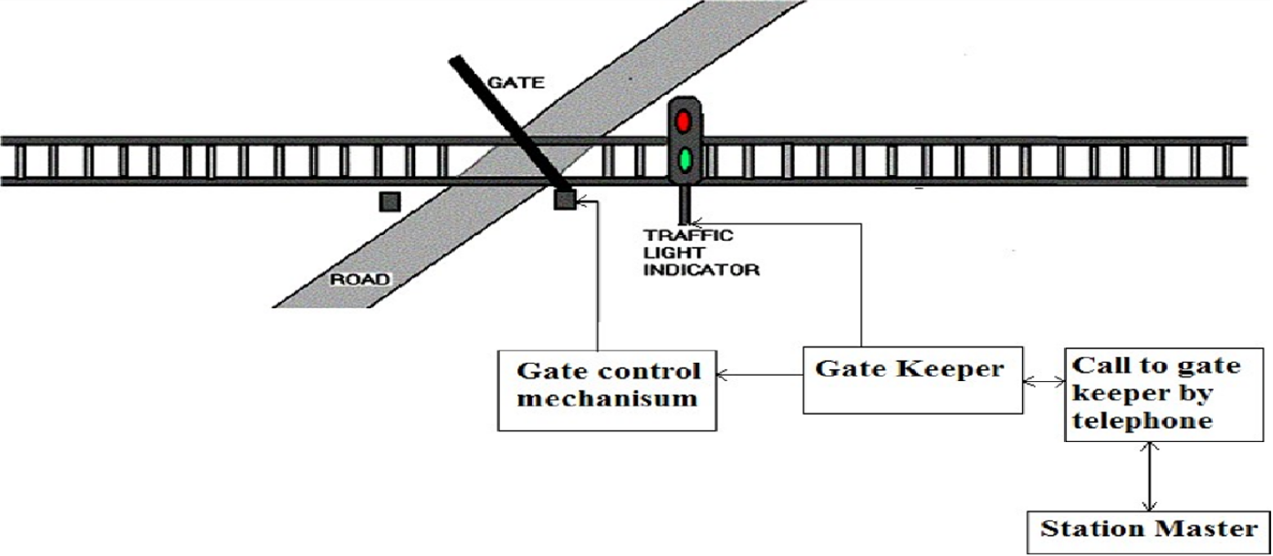
Fig 1.1
In the above fig 1.1 It says that currently the system used for the opening and closing of railway gate is traditionally operated through manual lever pulling method.

  - PROPOSED SYSTEM
In this project a smartphone mobile is used which contain Android app connect to railway. This Bluetooth module sends data to microcontroller. Due to APP, Now this signal goes to motor driver IC LM293D which has two input pins and two output pins and four ground pins. It require 12V supply. It drives the signal in specific direction. This signal goes to DC motor . DC Motor is used to open or close the gate. It works according to microcontroller. Whenever pin is set gate remains close and when pin reset becomes active, gate remains open.SO, Firstly gate remains open at railway gate as there is no any train passes from railway gate. Controller access signal from module and follows condition of set according to incoming signal and passes to DC motor through motor driver. Then DC motor close the gate .In this way DC motor rotates in clockwise and anticlockwise direction to open or close the gate. Whenever gate open or close , the status of gate candisplay on LCD and Alert through Buzzer.
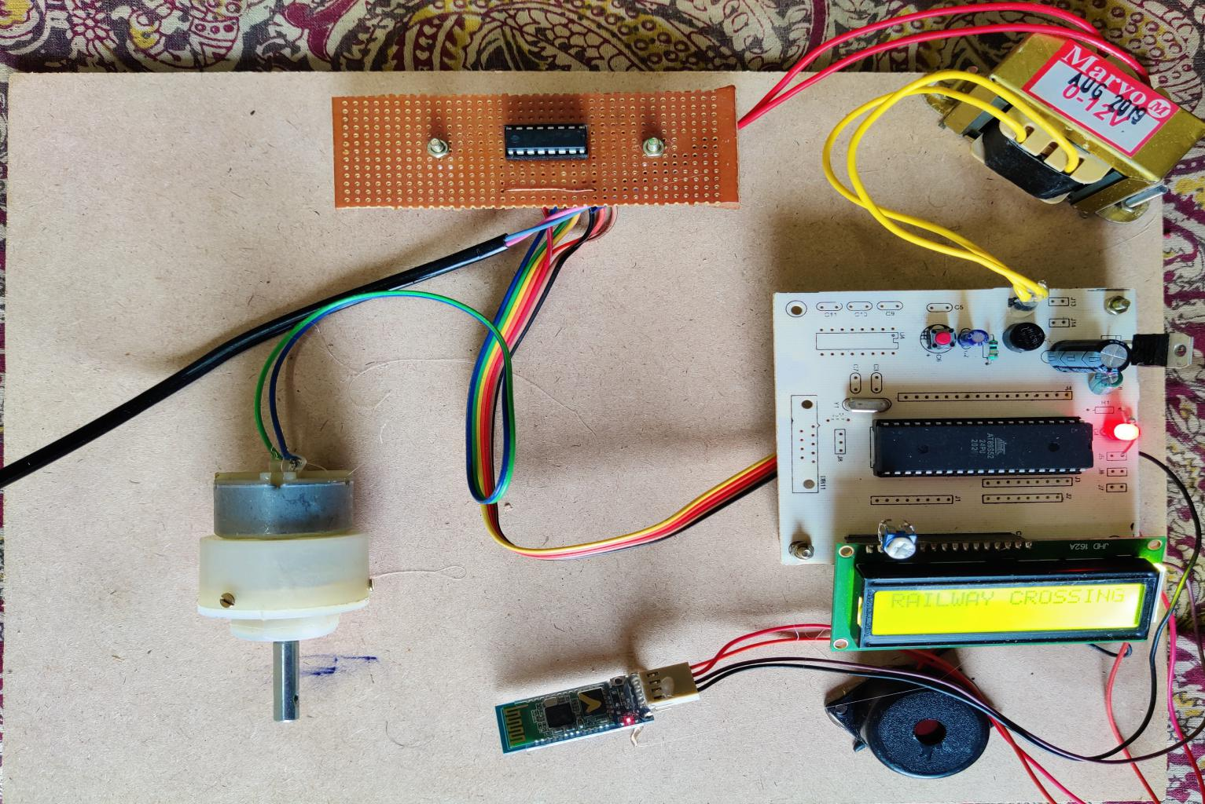

Fig 1.2
The fig 1.2 explains that system a smartphone mobile is used which contain Android app connect to railway.

CHAPTER 2
PROJECT DESCRIPTION
2.1 BLOCK DIAGRAM

Micro
Controller
MOTOR
Power Supply
Reset
L293D

LCD
BLUETOOTH
Crystal
Buzzer

BLOCK DIAGRAM EXPLANATION:
- Power supply is used to give the input power required to run the controller. It converts 230v AC supply to 5-12v DC Supply.
- Micro controller 8052 is used to take serial inputs and provide the required output.
- lcd is used to display the information to the reader in the form of message.
- A buzzer or beeper is a signaling device, usually electronic, typically used in automobiles, house hold appliances such as a microwave oven, or game shows.
- L293D IC is a typical Motor Driver IC which allows the DC motor to drive on any direction. This IC consists of 16-pins which are used to control a set of two DC motors instantaneously in any direction.
- The stepper motor converts a pulsing electrical current, controlled by a stepper motor driver, into precise one-step movements of this gear-like toothed component around a central shaft. Each of these stepper motor pulses moves the rotor through one precise and fixed increment of a full turn.
- HC-05 Bluetooth Module is an easy to use Bluetooth SPP (Serial Port Protocol) module, designed for transparent wireless serial connection setup. ... HC-05 Bluetooth module provides switching mode between master and slave mode which means it able to use neither receiving nor transmitting data

CHAPTER 3
HARDWARE REQUIREMENTS
3.1 POWER SUPPLY

The power supply section is the section which provide +5V for the components to work. IC LM7805 is used for providing a constant power of +5V.
Fig : Internal circuit diagram of power supply

The ac voltage, typically 220V, is connected to a transformer, which steps down that ac voltage down to the level of the desired dc output. A diode rectifier then provides a full-wave rectified voltage that is initially filtered by a simple capacitor filter to produce a dc voltage. This resulting dc voltage usually has some ripple or ac voltage variation.
Figure: Block Diagram of Power Supply

3.1.1 Transformer
Transformers convert AC electricity from one voltage to another with little loss of power.Step-up transformers increase voltage, step-down transformers reduce voltage. Most power supplies use a step-down transformer to reduce the dangerously high mains voltage (230V in India) to a safer low voltage.
The input coil is called the primary and the output coil is called the secondary. There is no electrical connection between the two coils; instead they are linked by an alternating magnetic field created in the soft-iron core of the transformer. Transformers waste very little power so the power out is (almost) equal to the power in. Note that as voltage is stepped down current is stepped up. The transformer will step down the power supply voltage (0-230V) to (0- 6V) level.
3.1.2 Rectifier
There are several ways of connecting diodes to make a rectifier to convert AC to DC. The bridge rectifier is the most important and it produces full-wave varying DC. A full-wave rectifier can also be made from just two diodes if a center-tap transformer is used, but this method is rarely used now that diodes are cheaper. A single diode can be used as a rectifier but it only uses the positive (+) parts of the AC wave to produce half-wave varying DC

Bridge Rectifier

When four diodes are connected as shown in figure, the circuit is called as bridge rectifier. The input to the circuit is applied to the diagonally opposite corners of the network, and the output is taken from the remaining two corners. Let us assume that the transformer is working properly and there is a positive potential, at point A and a negative potential at point B. the positive potential at point A will forward bias D3 and reverse bias D4.

Figure: Bridge Rectifier
The negative potential at point B will forward bias D1 and reverse D2. At this time D3 and D1 are forward biased and will allow current flow to pass through them; D4 and D2 are reverse biased and will block current flow.

One advantage of a bridge rectifier over a conventional full-wave rectifier is that with a given transformer the bridge rectifier produces a voltage output that is nearly twice that of the conventional full-wave circuit.

3.1.3 Voltage Regulators
Voltage regulators comprise a class of widely used ICs. Regulator IC units contain the circuitry for reference source, comparator amplifier, control device, and overload protection all in a single IC. IC units provide regulation of either a fixed positive voltage, a fixed negative voltage, or an adjustable set voltage. The regulators can be selected for operation with load currents from hundreds of milli amperes to tens of amperes, corresponding to power ratings from milli watts to Tens of watts.

A fixed three-terminal voltage regulator has an unregulated dc input voltage, Vi, applied to one input terminal, a regulated dc output voltage, Vo, from a second terminal, with the third terminal connected to ground.
The series 78 regulators provide fixed positive regulated voltages from 5 to 24 volts. Similarly, the series 79 regulators provide fixed negative regulated voltages from 5 to 24 volts. Voltage regulator ICs are available with fixed (typically 5, 12 and 15V) or variable output voltages. They are also rated by the maximum current they can pass. Negative voltage regulators are available, mainly for use in dual supplies. Most regulators include some automatic protection from excessive current ('overload protection') and overheating ('thermal protection').

Many of the fixed voltage regulator ICs has 3 leads and look like power transistors, such as the 7805 +5V 1Amp regulator. They include a hole for attaching a heat sink if necessary.

Figure: Regulator

3.2 MICROCONTROLLER

A Microcontroller (or MCU) is a computer-on-a-chip used to control electronic devices. It is a type of microprocessor emphasizing self-sufficiency and cost-effectiveness, in contrast to a general-purpose microprocessor (the kind used in a PC). A typical microcontroller contains all the memory and interfaces needed for a simple application, whereas a general purpose microprocessor requires additional chips to provide these functions.
A microcontroller is a single integrated circuit with the following key features:
- central processing unit - ranging from small and simple 8-bit processors to sophisticated 32- or 64-bit processors
- input/output interfaces such as serial ports
- RAM for data storage
- ROM, EEPROM or Flash memory for program storage
- clock generator - often an oscillator for a quartz timing crystal, resonator or RC circuit

Description
The AT89S52 is a low-power, high-performance CMOS 8-bit microcontroller with 8K bytes of in-system programmable Flash memory. The device is manufactured using Atmel’s high-density nonvolatile memory technology and is compatible with the industry-standard 80C51 instruction set and pin-out. The on-chip Flash allows the program memory to be reprogrammed in-system or by a conventional nonvolatile memory programmer. By combining a versatile 8-bit CPU with in-system programmable Flash on a monolithic chip, the Atmel AT89S52 is a powerful microcontroller which provides a highly-flexible and cost-effective solution to many embedded control applications.
The AT89S52 provides the following standard features: 8K bytes of Flash, 256 bytes of RAM, 32 I/O lines, three 16-bit timer/counters, a six-vector two-level interrupt architecture, a full duplex serial port, on-chip oscillator, and clock circuitry. In addition, the AT89S52 is designed with static logic for operation down to zero frequency and supports two software selectable power saving modes. The Idle Mode stops the CPU while allowing the RAM, timer/counters, serial port, and interrupt system to continue functioning. The Power-down mode saves the RAM con-tents but freezes the oscillator, disabling all other chip functions until the next interrupt or hardware reset.
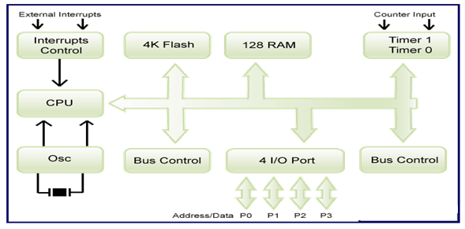
Fig. BLOCK DIAGRAM OF 8052

PIN DIAGRAM
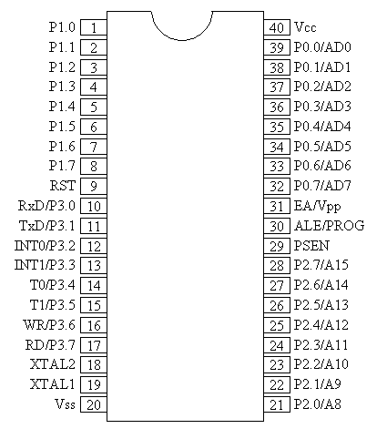
Fig. PIN DIAGRAM OF 8052
3.2.1 PIN DESCRIPTION
40 pin VCC Supply voltage.
20 pin GND Ground.
Port 0
Port 0 is an 8-bit open drain bidirectional I/O port. As an output port, each pin can sink eight TTL inputs. When 1s are written to port 0 pins, the pins can be used as high-impedance inputs. Port 0 can also be configured to be the multiplexed low-order address/data bus during accesses to external program and data memory. Port 0 also receives the code bytes during Flash programming and outputs the code bytes during program verification. External pull-ups are required during program verification.
Port 1
Port 1 is an 8-bit bidirectional I/O port with internal pull-ups. The Port 1 output buffers can sink/source four TTL inputs. When 1s are written to Port 1 pins, they are pulled high by the internal pull-ups and can be used as inputs. As inputs, Port 1 pins that are externally being pulled low will source current (IIL) because of the internal pull-ups.
Port 2
Port 2 is an 8-bit bidirectional I/O port with internal pull-ups. The Port 2 output buffers can sink/source four TTL inputs. When 1s are written to Port 2 pins, they are pulled high by the internal pull-ups and can be used as inputs. As inputs, Port 2 pins that are externally being pulled low will source current because of the internal pull-ups. In this application, Port 2 uses strong internal pull-ups when emitting 1s. During accesses to external data memory that use 8-bit addresses, Port 2 emits the contents of the P2 Special Function Register. Port 2 also receives the high-order address bits and some control signals during Flash programming and verification.
Port 3
Port 3 is an 8-bit bidirectional I/O port with internal pull-ups. The Port 3 output buffers can sink/source four TTL inputs. When 1s are written to Port 3 pins, they are pulled high by the internal pull-ups and can be used as inputs. As inputs, Port 3 pins that are externally being pulled low will source current because of the pull-ups. Port 3 also serves the functions of various special features of the AT89S52, as shown in the following table.
RST
Reset input. A high on this pin for two machine cycles while the oscillator is running resets the device.
WR
It is active low write O/P control signal. During External RAM (Data memory). Write to external RAM.
RD
It is active low read O/P control signal. During External RAM (Data memory). Read from External RAM.
XTAL1 Input to the inverting oscillator amplifier and input to the internal clock operating circuit.
XTAL2 Output from the inverting oscillator amplifier.
ALE/PROG
Address Latch Enable (ALE) is an output pulse for latching the low byte of the address during accesses to external memory. This pin is also the program pulse input (PROG) during Flash programming. In normal operation, ALE is emitted at a constant rate of 1/6 the oscillator frequency and may be used for external timing or clocking purposes. If desired, ALE operation can be disabled by setting bit 0 of SFR location 8EH. With the bit set, ALE is active only during a MOVX or MOVC instruction. Otherwise, the pin is weakly pulled high. Setting the ALE-disable bit has no effect if the microcontroller is in external execution mode.
PSEN
Program Store Enable (PSEN) is the read strobe to external program memory. When the AT89S52 is executing code from external program memory, PSEN is activated twice each machine cycle.
EA
External Access Enable. EA must be strapped to GND in order to enable the device to fetch code from external program memory locations starting at 0000H up to FFFFH. Note, however, that if lock bit 1 is programmed, EA will be internally latched on reset. EA should be strapped to VCC for internal program executions.

3.2.2 FEATURES
• Compatible with MCU®-51 Products
• 8K Bytes of In-System Programmable (ISP) Flash Memory
– Endurance: 10,000 Write/Erase Cycles
• 4.0V to 5.5V Operating Range
• Fully Static Operation: 0 Hz to 33 MHz
• 256 x 8-bit Internal RAM
• 32 Programmable I/O Lines
• Three 16-bit Timer/Counters
• Eight Interrupt Sources
• Full Duplex UART Serial Channel
• Low-power Idle and Power-down Modes
• Interrupt Recovery from Power-down Mode
• Fast Programming Time

3.2.3 ARCHITECTURE OF 8052
Fig. INTERNAL ARCHITECTURE OF 8052

3.2.4 REGISTERS

Registers and accumulators serve as temporary memory locations during CPU operations. The exchange of information among them takes place through one or more internal buses. The length of each register is equal to the width of the internal data bus.

Registers are categorized as general-purpose registers and special-purpose registers.

A general-purpose register may be used as an accumulator or as a data register for (arithmetic) and logic operations. An accumulator is a register for storing the results of an arithmetic operation. A general-purpose register may also be used as an address register.

3.2.5 Memory Organization
MCU-51 devices have a separate address space for Program and Data Memory. Up to 64K bytes each of external Program and Data Memory can be addressed.
The instructions to be executed by the microcontroller CPU and the data to be operated on by these instructions are stored in memory. When the CPU accesses the information stored in memory, it is performing a read operation. When the CPU sends information to be stored in the memory, it is performing a write operation. Memory is classified as internal and external memory. Internal memory is on-chip memory and is a semiconductor type with low capacity and high speeds. External memory is outside the chip and includes the semiconductor type and serial memory such as magnetic disks, magnetic tapes, and bubble memory. Semiconductor memory may be volatile or nonvolatile. Volatile memory loses its contents after the power is removed from the memory chip. Nonvolatile memory does not lose its contents when power is removed. The nonvolatile memory can store information permanently or at least semi-permanently (ten years or more)
Data Memory
The AT89S52 implements 256 bytes of on-chip RAM. The upper 128 bytes occupy a parallel address space to the Special Function Registers. This means that the upper 128 bytes have the same addresses as the SFR space but are physically separate from SFR space.
When an instruction accesses an internal location above address 7FH, the address mode used in the instruction specifies whether the CPU accesses the upper 128 bytes of RAM or the SFR space. Instructions which use direct addressing access the SFR space.

UART (Universal Asynchronous Receiver and Transmitter)

One of the microcontroller features making it so powerful is an integrated UART, better known as a serial port. It is a full-duplex port, thus being able to transmit and receive data simultaneously and at different baud rates. Without it, serial data send and receive would be an enormously complicated part of the program in which the pin state is constantly changed and checked at regular intervals. When using UART, all the programmer has to do is to simply select serial port mode and baud rate. When it's done, serial data transmit is nothing but writing to the SBUF register, while data receive represents reading the same register. The microcontroller takes care of not making any error during data transmission.
TIMERS
Timer is use to generate time delay, a timer always counts up. It doesn’t matter whether the timer is being used as a timer, a counter, or a baud rate generator: A timer is always incremented by the microcontroller. There are 3 timers i.e., Timer 0, Timer 1 and Timer 2.
Timer 0 and 1
Timer 0 and Timer 1 in the AT89S52 operate the same way as Timer 0 and Timer 1 in the 8051.
Timer T0 is a 16 bit timer. The 16-bit Timer 0 is accessed as low byte and high byte. the low byte is called TL0(Timer 0 low byte)and the high byte is referred to as TH0(Timer 0 high byte).
As like Timer 1 is also 16-bit timer is split into two bytes, referred to as TL1 (Timer 1 low byte) and TH1(Timer 1 high byte). These timer are accessible in the same way as the Timer 0.
Timer 2
Timer 2 is a 16-bit Timer/Counter that can operate as either a timer or an event counter. The type of operation is selected by bit C/T2 in the SFR T2CON (shown in Table 5-2). Timer 2 has three operating modes: capture, auto-reload (up or down counting), and baud rate generator. Timer 2 consists of two 8-bit registers, TH2 and TL2. In the Timer function, the TL2 register is incremented every machine cycle. Since a machine cycle consists of 12 oscillator periods, the count rate is 1/12 of the oscillator frequency.
In the Counter function, the register is incremented in response to a 1-to-0 transition at its corresponding external input pin, T2. In this function, the external input is sampled during S5P2 of every machine cycle. When the samples show a high in one cycle and a low in the next cycle, the count is incremented. The new count value appears in the register during S3P1 of the cycle following the one in which the transition was detected. Since two machine cycles (24 oscillator periods) are required to recognize a 1-to-0 transition, the maximum count rate is 1/24 of the oscillator frequency. To ensure that a given level is sampled at least once before it changes, the level should be held for at least one full machine cycle.
INTERRUPTS
The AT89S52 has a total of six interrupt vectors: two external interrupts (INT0 and INT1), three timer interrupts (Timers 0, 1, and 2), and the serial port interrupt.
Each of these interrupt sources can be individually enabled or disabled by setting or clearing a bit in Special Function Register IE. IE also contains a global disable bit, EA, which disables all interrupts at once.
Timer 2 interrupt is generated by the logical OR of bits TF2 and EXF2 in register T2CON. Neither of these flags is cleared by hardware when the service routine is vectored to. In fact, the service routine may have to determine whether it was TF2 or EXF2 that generated the interrupt, and that bit will have to be cleared in software.
The Timer 0 and Timer 1 flags, TF0 and TF1, uses the cycle in which the timers overflow. The values are then polled by the circuitry in the next cycle. However, the Timer 2 flag, TF2, is set at S2P2 and is polled in the same cycle in which the timer overflows.

3.3 LIQUID CRYSTAL DISPLAY
3.3.1 INTRODUCTION

LCD (Liquid Crystal Display) screen is an electronic display module and find a wide range of applications. A 16x2 LCD display is very basic module and is very commonly used in various devices and circuits. These modules are preferred over seven segments and other multi segment LEDs. The reasons being: LCDs are economical; easily programmable; have no limitation of displaying special & even custom characters (unlike in seven segments), animations and so on.
A 16x2 LCD means it can display 16 characters per line and there are 2 such lines. In this LCD each character is displayed in 5x7 pixel matrix. This LCD has two registers, namely, Command and Data.
The command register stores the command instructions given to the LCD. A command is an instruction given to LCD to do a predefined task like initializing it, clearing its screen, setting the cursor position, controlling display etc. The data register stores the data to be displayed on the LCD. The data is the ASCII value of the character to be displayed on the LCD.

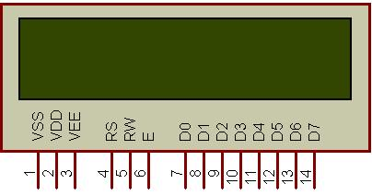
Fig3.3: 16x2 LCD

Fig 3.3 shows LCD (Liquid Crystal Display) screen is an electronic display module and find a wide range of applications. A 16x2 LCD display is very basic module and is very commonly used in various devices and circuits. These modules are preferred over seven segments and other multi segment LEDs. The reasons being: LCDs are economical; easily programmable; have no limitation of displaying special & even custom characters (unlike in seven segments), animations and so on.

3.3.2 WORKING PRINCIPLE
A liquid-crystal display (LCD) is a flat-panel display or other electronically modulated optical device that uses the light-modulating properties of liquid crystals combined with polarizers. Liquid crystals do not emit light directly,[1] instead using a backlight or reflector to produce images in color or monochrome.[2] LCDs are available to display arbitrary images (as in a general-purpose computer display) or fixed images with low information content, which can be displayed or hidden, such as preset words, digits, and seven-segment displays, as in a digital clock.

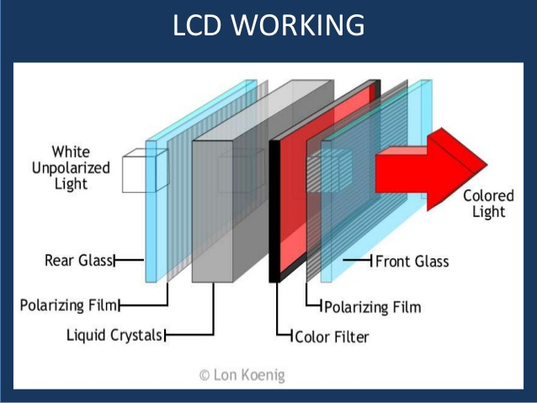

3.3.3 Pin Description
Most LCDs with 1 controller has 14 Pins and LCDs with 2 controller has 16 Pins (two pins are extra in both for back-light LED connections). Pin description is shown in the table below.

Pin Configuration table for a 16X2 LCD character display:-
Pin Number | Symbol | Function
1 | Vss | Ground Terminal
2 | Vcc | Positive Supply
3 | Vdd | Contrast adjustment
4 | RS | Register Select; 0→Instruction Register, 1→Data Register
5 | R/W | Read/write Signal; 1→Read, 0→ Write
6 | E | Enable; Falling edge
7 | DB0 | Bi-directional data bus, data transfer is performed once, thru DB0 to DB7, in the case of interface data length is 8-bits; and twice, through DB4 to DB7 in the case of interface data length is 4-bits. Upper four bits first then lower four bits.
8 | DB1
9 | DB2
10 | DB3
11 | DB4
12 | DB5
13 | DB6
14 | DB7
15 | LED-(K) | Back light LED cathode terminal
16 | LED+(A) | Back Light LED anode terminal
Fig: Pin Configuration of LCD

3.3.4 Data/Signals/Execution of LCD
LCD accepts two types of signals, one is data, and another is control. These signals are recognized by the LCD module from status of the RS pin. Now data can be read also from the LCD display, by pulling the R/W pin high. As soon as the E pin is pulsed, LCD display reads data at the falling edge of the pulse and executes it, same for the case of transmission.
LCD display takes a time of 39-43µS to place a character or execute a command. Except for clearing display and to seek cursor to home position it takes 1.53ms to 1.64ms. Any attempt to send any data before this interval may lead to failure to read data or execution of the current data in some devices. Some devices compensate the speed by storing the incoming data to some temporary registers.
Instruction Register (IR) and Data Register (DR)
There are two 8-bit registers in HD44780 controller Instruction and Data register. Instruction register corresponds to the register where you send commands to LCD e.g LCD shift command, LCD clear, LCD address etc. and Data register is used for storing data which is to be displayed on LCD. When send the enable signal of the LCD is asserted, the data on the pins is latched in to the data register and data is then moved automatically to the DDRAM and hence is displayed on the LCD. Data Register is not only used for sending data to DDRAM but also for CGRAM, the address where you want to send the data, is decided by the instruction you send to LCD. We will discuss more on LCD instruction set further in this tutorial.

3.3.5 Commands and Instruction set
Only the instruction register (IR) and the data register (DR) of the LCD can be controlled by the MCU. Before starting the internal operation of the LCD, control information is temporarily stored into these registers to allow interfacing with various MCUs, which operate at different speeds, or various peripheral control devices. The internal operation of the LCD is determined by signals sent from the MCU. These signals, which include register selection signal (RS), read/write signal (R/W), and the data bus (DB0 to DB7), make up the LCD instructions (Table 3). There are four categories of instructions that:
- Designate LCD functions, such as display format, data length, etc.
- Set internal RAM addresses
- Perform data transfer with internal RAM
- Perform miscellaneous functions
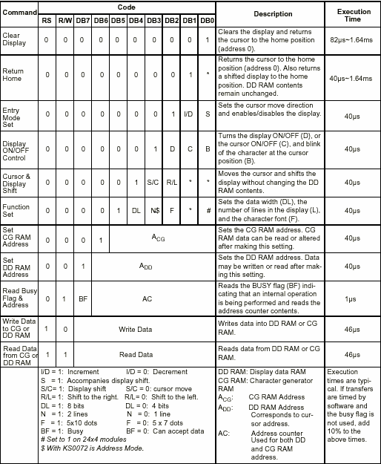
Fig: Code for LCD
Although looking at the table you can make your own commands and test them. Below is a brief list of useful commands which are used frequently while working on the LCD.

List of Command
No. | Instruction | Hex | Decimal
1 | Function Set: 8-bit, 1 Line, 5x7 Dots | 0x30 | 48
2 | Function Set: 8-bit, 2 Line, 5x7 Dots | 0x38 | 56
3 | Function Set: 4-bit, 1 Line, 5x7 Dots | 0x20 | 32
4 | Function Set: 4-bit, 2 Line, 5x7 Dots | 0x28 | 40
5 | Entry Mode | 0x06 | 6
6 | Display off Cursor off  (clearing display without clearing DDRAM content) | 0x08 | 8
7 | Display on Cursor on | 0x0E | 14
8 | Display on Cursor off | 0x0C | 12
9 | Display on Cursor blinking | 0x0F | 15
10 | Shift entire display left | 0x18 | 24
12 | Shift entire display right | 0x1C | 30
13 | Move cursor left by one character | 0x10 | 16
14 | Move cursor right by one character | 0x14 | 20
15 | Clear Display (also clear DDRAM content) | 0x01 | 1
16 | Set DDRAM address or cursor position on display | 0x80+add* | 128+add*
17 | Set CGRAM address or set pointer to CGRAM location | 0x40+add** | 64+add**

Table: Frequently used commands and instructions for LCD

3.3.6 INTERFACING DIAGRAM OF LCD WITH 8052:
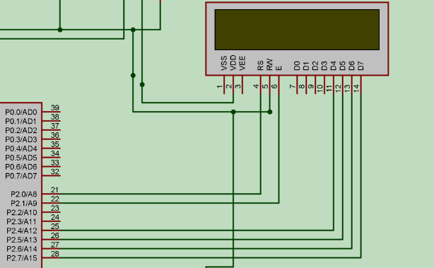
Liquid crystal displays interfacing with Controller
The LCD standard requires 3 control lines and 8 I/O lines for the data bus.
• 8 data pins D7:D0
Bi-directional data/command pins.
Alphanumeric characters are sent in ASCII format.
• RS: Register Select
RS = 0 -> Command Register is selected
RS = 1 -> Data Register is selected
• R/W: Read or Write
0 -> Write, 1 -> Read
• E: Enable (Latch data)
Used to latch the data present on the data pins.
A high-to-low edge is needed to latch the data.

3.4 BLUETOOTH
Bluetooth is a wireless technology standard for exchanging data over short distances (using short-wavelength UHF radio waves in the ISM band from 2.4 to 2.485 GHz) from fixed and mobile devices and building personal area networks (PANs).
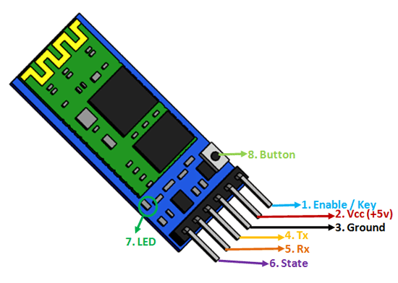

Some specification of Bluetooth
• Operates in the 2.4 GHZ band which is globally available
• It has 79 channels
• 1600 hops per second
• Can support up to 8 devices in a piconet
• Omni-directional, non-line of sight transmission through walls
• 10m to 100m range
• Low cost, ₹200
• 1mW power

Communication
A Bluetooth transceiver is a frequency hopping spread-spectrum (FHSS) device that uses the unlicensed (worldwide) 2.4 GHz ISM (Industrial, Scientific, Medical) frequency band. In most countries, there are 79 channels available. The nominal bandwidth for each channel is 1MHz. When connected to other Bluetooth devices, a Bluetooth device hops (changes frequencies) at the rate of 1600 times per second for typical use, with a residence time of 625 µsec.

Bluetooth Module
Baseband - There are two basic types of physical links that can be established between a master and a slave:
- Synchronous Connection Oriented (SCO)
- Asynchronous Connection-Less (ACL)

An SCO link provides a symmetric link between the master and the slave, with regular periodic exchange of data in the form of reserved slots. Thus, the SCO link provides a circuit-switched connection where data are regularly exchanged, and as such it is intended for use with time-bounded information as audio. A master can support up to three SCO links to the same or to different slaves. A slave can support up to three SCO links from the same master.

Access Code
Header
Payload
0 - 2745 bits
54 bits
68 or 72 bits
Figure: Bluetooth packet structure
The access code is used to address the packet to a specific device. The header contains all the control information associated with the packet and the link. The payload contains the actual message information. The Bluetooth packets can be 1, 3, or 5 slots long, but the multi slot packets are always sent on a single-hop carrier.

BLUETOOTH INTERFACING WITH MICRO-CONTROLLER

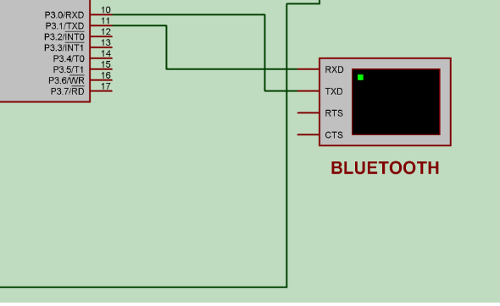

POWER MANAGEMENT
As many Bluetooth devices are operated by batteries, special attention has been paid to the reduction of power consumption in the design. And many tests have been done to prove that Bluetooth devices are too low in power to have any negative impact on health. Three low-power modes, which extend battery life by reducing activity on a connection, have been defined. These modes are called Park, Hold, and Sniff.

3.5 DRIVER CIRCUIT (L293D)
INTRODUCTION
L293D IC generally comes as a standard 16-pin DIP (dual-in line package). This motor driver IC can simultaneously control two small motors in either direction; forward and reverse with just 4 microcontroller pins (if you do not use enable pins).
Some of the features (and drawbacks) of this IC are:
- Output current capability is limited to 600mA per channel with peak output current limited to 1.2A (non-repetitive). This means you cannot drive bigger motors with this IC. However, most small motors used in hobby robotics should work. If you are unsure whether the IC can handle a particular motor, connect the IC to its circuit and run the motor with your finger on the IC. If it gets really hot, then beware... Also note the words "non-repetitive"; if the current output repeatedly reaches 1.2A, it might destroy the drive transistors.
- Supply voltage can be as large as 36 Volts. This means you do not have to worry much about voltage regulation.
- L293D has an enable facility which helps you enable the IC output pins. If an enable pin is set to logic high, then state of the inputs match the state of the outputs. If you pull this low, then the outputs will be turned off regardless of the input states
- The datasheet also mentions an "over temperature protection" built into the IC. This means an internal sensor senses its internal temperature and stops driving the motors if the temperature crosses a set point
- Another major feature of L293D is its internal clamp diodes. This flyback diode helps protect the driver IC from voltage spikes that occur when the motor coil is turned on and off (mostly when turned off)
- The logical low in the IC is set to 1.5V. This means the pin is set high only if the voltage across the pin crosses 1.5V which makes it suitable for use in high frequency applications like switching applications (upto 5KHz)

Description
It works on the concept of H-bridge. H-bridge is a circuit which allows the voltage to be flown in either direction
There are two Enable pins on l293d. Pin 1 and pin 9, for being able to drive the motor, the pin 1 and 9 need to be high. For driving the motor with left H-bridge you need to enable pin 1 to high. And for right H-Bridge you need to make the pin 9 to high. If anyone of the either pin1 or pin9 goes low then the motor in the corresponding section will suspend working. It’s like a switch.
Pin Diagram

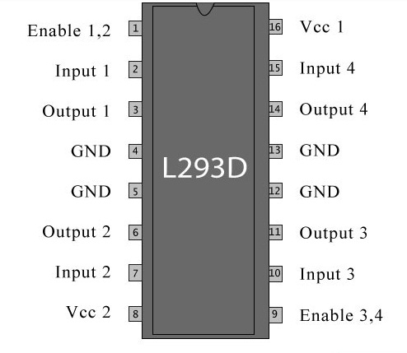

Fig showing pin diagram of L293D

Pin Description

Pin No | Function | Name
1 | Enable pin for Motor 1; active high | Enable 1,2
2 | Input 1 for Motor 1 | Input 1
3 | Output 1 for Motor 1 | Output 1
4 | Ground (0V) | Ground
5 | Ground (0V) | Ground
6 | Output 2 for Motor 1 | Output 2
7 | Input 2 for Motor 1 | Input 2
8 | Supply voltage for Motors; 9-12V (up to 36V) | Vcc ₂
9 | Enable pin for Motor 2; active high | Enable 3,4
10 | Input 1 for Motor 1 | Input 3
11 | Output 1 for Motor 1 | Output 3
12 | Ground (0V) | Ground
13 | Ground (0V) | Ground
14 | Output 2 for Motor 1 | Output 4
15 | Input2 for Motor 1 | Input 4
16 | Supply voltage; 5V (up to 36V) | Vcc ₁

Table :Pin Description of L293D

Working of L293D
The 4 input pins for this l293d, pin 2,7 on the left and pin 15 ,10 on the right as shown on the pin diagram. Left input pins will regulate the rotation of motor connected across left side and right input for motor on the right hand side. The motors are rotated on the basis of the inputs provided across the input pins as LOGIC 0 or LOGIC 1.
In simple you need to provide Logic 0 or 1 across the input pins for rotating the motor.
DRIVER CIRCUIT INTERFACING WITH MICRO-CONTROLLER
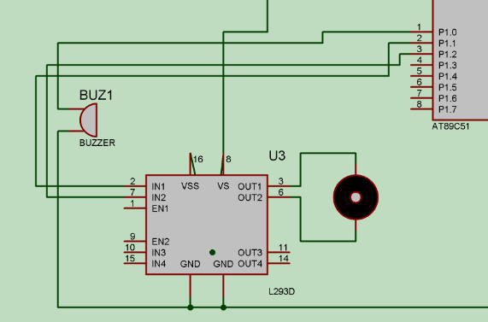

Voltage Specification
VCC is the voltage that it needs for its own internal operation 5v; L293D will not use this voltage for driving the motor. For driving the motor it has a separate provision to provide motor supply VSS (V supply). L293d will use this to drive the motor. It means if you want to operate a motor at 9V then you need to provide a Supply of 9V across VSS Motor supply.
The maximum voltage for VSS motor supply is 36V. It can supply a max current of 600mA per channel. Since it can drive motors Up to 36v hence you can drive pretty big motors with this l293d.
VCC pin 16 is the voltage for its own internal Operation. The maximum voltage ranges from 5v and up to 36v.

3.6 DC MOTOR
A DC motor in simple words is a device that converts direct current(electrical energy) into mechanical energy. It’s of vital importance for the industry today.
A DC motor is designed to run on DC electric power. Two examples of pure DC designs are Michael Faraday's homo-polar motor (which is uncommon), and the ball bearing motor, which is (so far) a novelty.

By far the most common DC motor types are the brushed and brushless types, which use internal and external commutation respectively to create an oscillating AC current from the DC source—so they are not purely DC machines in a strict sense.

We in our project are using brushed DC Motor, which will operate in the ratings of 12v DC 0.6A.
The speed of a DC motor can be controlled by changing the voltage applied to the armature or by changing the field current. The introduction of variable resistance in the armature circuit or field circuit allowed speed control. Modern DC motors are often controlled by power electronics systems called DC drives.

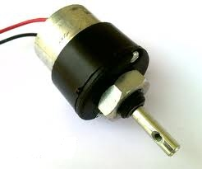
Fig. Motor

3.7 BUZZER
A buzzer or beeper is a signaling device, usually electronic, typically used in automobiles, house hold appliances such as a microwave oven, or game shows.
It most commonly consists of a number of switches or sensors connected to a control unit that determines if and which button was pushed or a preset time has lapsed, and usually illuminates a light on the appropriate button or control panel, and sounds a warning in the form of a continuous or intermittent buzzing or beeping sound. Initially this device was based on an electromechanical system which was identical to an electric bell without the metal gong (which makes the ringing noise). Often these units were anchored to a wall or ceiling and used the ceiling or wall as a sounding board. Another implementation with some AC-connected devices was to implement a circuit to make the AC current into a noise loud enough to drive a loudspeaker and hook this circuit up to a cheap 8-ohm speaker. Nowadays, it is more popular to use a ceramic-based piezoelectric sounder like a Sonalert which makes a high-pitched tone. Usually these were hooked up to “driver” circuits which varied the pitch of the sound or pulsed the sound on and off.
In game shows it is also known as a “lockout system,” because when one person signals (“buzzes in”), all others are locked out from signalling. Several game shows have large buzzer buttons which are identified as “plungers”.
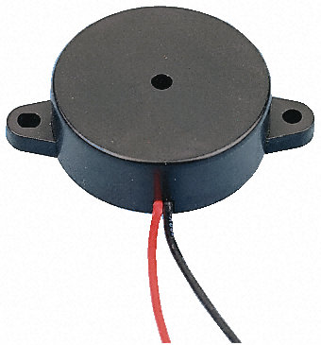
Fig. Buzzer

CHAPTER 4
SOFTWARE SPECIFICATION

KEIL SOFTWARE
Keil compiler is a software used where the machine language code is written and compiled. After compilation, the machine source code is converted into hex code which is to be dumped into the microcontroller for further processing. Keil compiler also supports C language code.
General Introduction
Keil Software is the leading vendor for 8/16-bit development tools (ranked at first position in the 2004 Embedded Market Study of the Embedded Systems and EE Times magazine). Keil Software is represented world-wide in more than 40 countries. Since the market introduction in 1988, the Keil C51 Compiler is the de facto industry standard and supports more than 500 current 8051 device variants. Now, Keil Software offers development tools for ARM.
Keil Software makes C compilers, macro assemblers, real-time kernels, debuggers, simulators, integrated environments, and evaluation boards for the 8051, 251, ARM, and XC16x/C16x/ST10 microcontroller families.
Keil Software is pleased to announce simulation support for the Atmel AT91 ARM family of microcontrollers. The Keil µVision Debugger simulates the complete ARM instruction-set as well as the on-chip peripherals for each device in the AT91 ARM/Thumb microcontroller family. The integrated simulator provides complete peripheral simulation. Other new features in the µVision Debugger include:
- An integrated Software Logic Analyzer that measures I/O signals as well as program variables and helps developers create complex signal processing algorithms.
- An Execution Profiler that measures time spent in each function, source line, and assembler instruction. Now developers can find exactly where programs spend the most time.
"Using nothing more than the provided simulation support and debug scripts, developers can create a high-fidelity simulation of their actual target hardware and environment. No extra hardware or test equipment is required. The Logic Analyzer and Execution Profiler will help developers when it comes time to develop and tune signaling algorithms." said Jon Ward, President of Keil Software USA, Inc.

µVision3 Overview
The µVision3 IDE is a Windows-based software development platform that combines a robust editor, project manager, and makes facility. µVision3 integrates all tools including the C compiler, macro assembler, linker/locator, and HEX file generator. µVision3 helps expedite the development process of your embedded applications by providing the following:
- Full-featured source code editor,
- Device database for configuring the development tool setting,
- Project manager for creating and maintaining your projects,
- Integrated make facility for assembling, compiling, and linking your embedded applications,
- Dialogs for all development tool settings,
- True integrated source-level Debugger with high-speed CPU and peripheral simulator,
- Advanced GDI interface for software debugging in the target hardware and for connection to Keil ULINK,
- Flash programming utility for downloading the application program into Flash ROM,
- Links to development tools manuals, device datasheets & user’s guides.
The µVision3 IDE offers numerous features and advantages that help you quickly and successfully develop embedded applications. They are easy to use and are guaranteed to help you achieve your design goals.
The µVision3 IDE and Debugger is the central part of the Keil development tool chain. µVision3 offers a Build Mode and a Debug Mode.
In the µVision3 Build Mode you maintain the project files and generate the application.
In the µVision3 Debug Mode you verify your program either with a powerful CPU and peripheral simulator or with the Keil ULINK USB-JTAG Adapter (or other AGDI drivers) that connect the debugger to the target system. The ULINK allows you also to download your application into Flash ROM of your target system.

STEPS TO WRITE AN ASSEMBLY LANGUAGE PROGRAM IN KEIL AND HOW TO COMPILE IT:

- Install the Keil Software in the PC in any of the drives.
- After installation, an icon will be created with the name “Keil uVision3”. Just drag this icon onto the desktop so that it becomes easy whenever you try to write programs in keil.
- Double click on this icon to start the keil compiler.
- A page opens with different options in it showing the project workspace at the leftmost corner side, output window in the bottom and an ash coloured space for the program to be written.
- Now to start using the keil, click on the option “project”.
- A small window opens showing the options like new project, import project, open project etc. Click on “New project”.
- A small window with the title bar “Create new project” opens. The window asks the user to give the project name with which it should be created and the destination location. The project can be created in any of the drives available. You can create a new folder and then a new file or can create directly a new file.
- After the file is saved in the given destination location, a window opens where a list of vendors will be displayed and you have to select the device for the target you have created.
- The most widely used vendor is Atmel. So click on Atmel and now the family of microcontrollers manufactured by Atmel opens. You can select any one of the microcontrollers according to the requirement.
- When you click on any one of the microcontrollers, the features of that particular microcontroller will be displayed on the right side of the page. The most appropriate microcontroller with which most of the projects can be implemented is the AT89C51. Click on this microcontroller and have a look at its features. Now click on “OK” to select this microcontroller.
- A small window opens asking whether to copy the startup code into the file you have created just now. Just click on “No” to proceed further.
- Now you can see the TARGET and SOURCE GROUP created in the project workspace.
- Now click on “File” and in that “New”. A new page opens and you can start writing program in it.
- After the program is completed, save it with any name but with the .asm extension. Save the program in the file you have created earlier.
- You can notice that after you save the program, the predefined keywords will be highlighted in bold letters.
- Now add this file to the target by giving a right click on the source group. A list of options open and in that select “Add files to the source group”. Check for this file where you have saved and add it.
- Right click on the target and select the first option “Options for target”. A window opens with different options like device, target, output etc. First click on “target”.
- Since the set frequency of the microcontroller is 11.0592 MHz to interface with the PC, just enter this frequency value in the Xtal (MHz) text area and put a tick on the Use on-chip ROM. This is because the program what we write here in the keil will later be dumped into the microcontroller and will be stored in the inbuilt ROM in the microcontroller.
- Now click the option “Output” and give any name to the hex file to be created in the “Name of executable” text area and put a tick to the “Create HEX file” option present in the same window. The hex file can be created in any of the drives. You can change the folder by clicking on “Select folder for Objects”.
- Now to check whether the program you have written is errorless or not, click on the icon exactly below the “Open file” icon which is nothing but Build Target icon. You can even use the shortcut key F7 to compile the program written.
- To check for the output, there are several windows like serial window, memory window, project window etc. Depending on the program you have written, select the appropriate window to see the output by entering into debug mode.
- The icon with the letter “d” indicates the debug mode.
- Click on this icon and now click on the option “View” and select the appropriate window to check for the output.
- After this is done, click the icon “debug” again to come out of the debug mode.
- The hex file created as shown earlier will be dumped into the microcontroller with the help of another software called Proload/Topwin.

CHAPTER 5
IMPLEMENTATION

5.1 SCHEMATIC DIAGRAM:
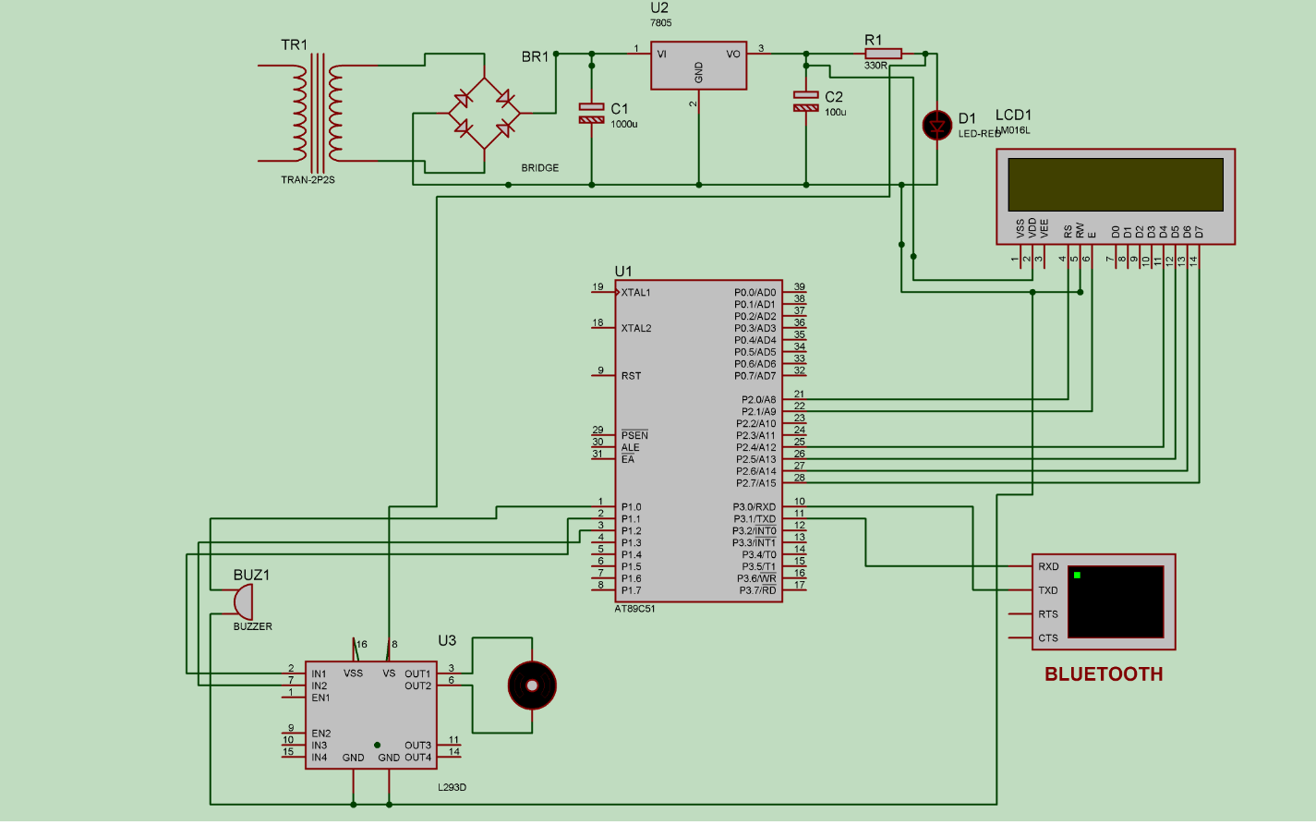

5.2 FLOW CHART:

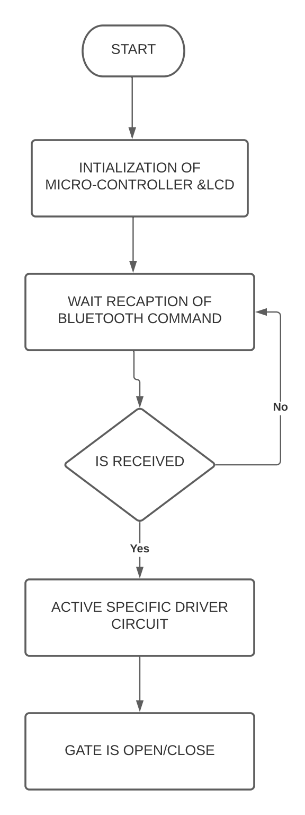

CHAPTER 6
SIMULATION AND DESIGN

5.1 OUTPUT SCREEN SHOTS
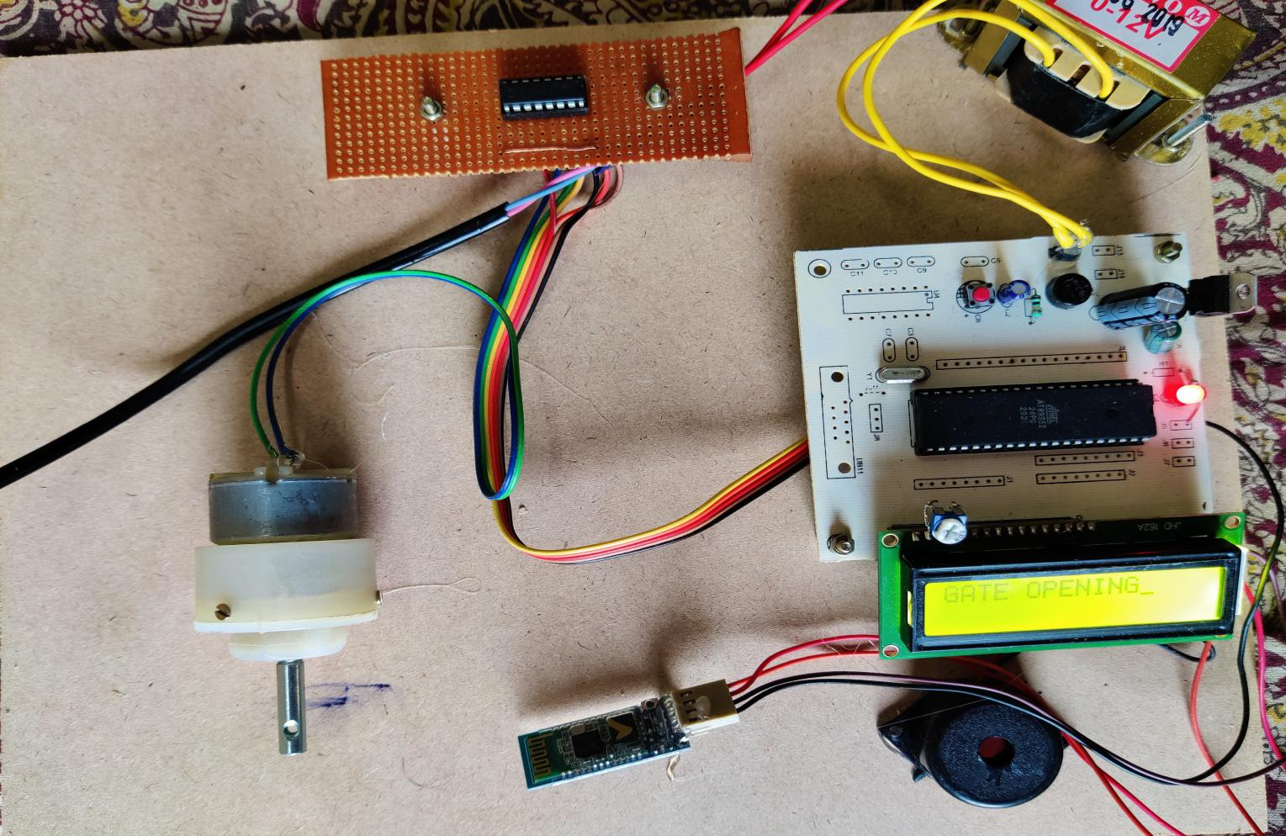

The above figure is One of the outputs of this kit is displaying message on LCD screen and the other one is in the form of sound which comes from buzzer. After the input from the operator is obtained all the internal processes are carried out and the output is sent to LCD and buzzer.A predefined value is assigned for Gate Closing.The Bluetooth detects the input ASCII command “O” and diaplays the message “GATE OPENING”.

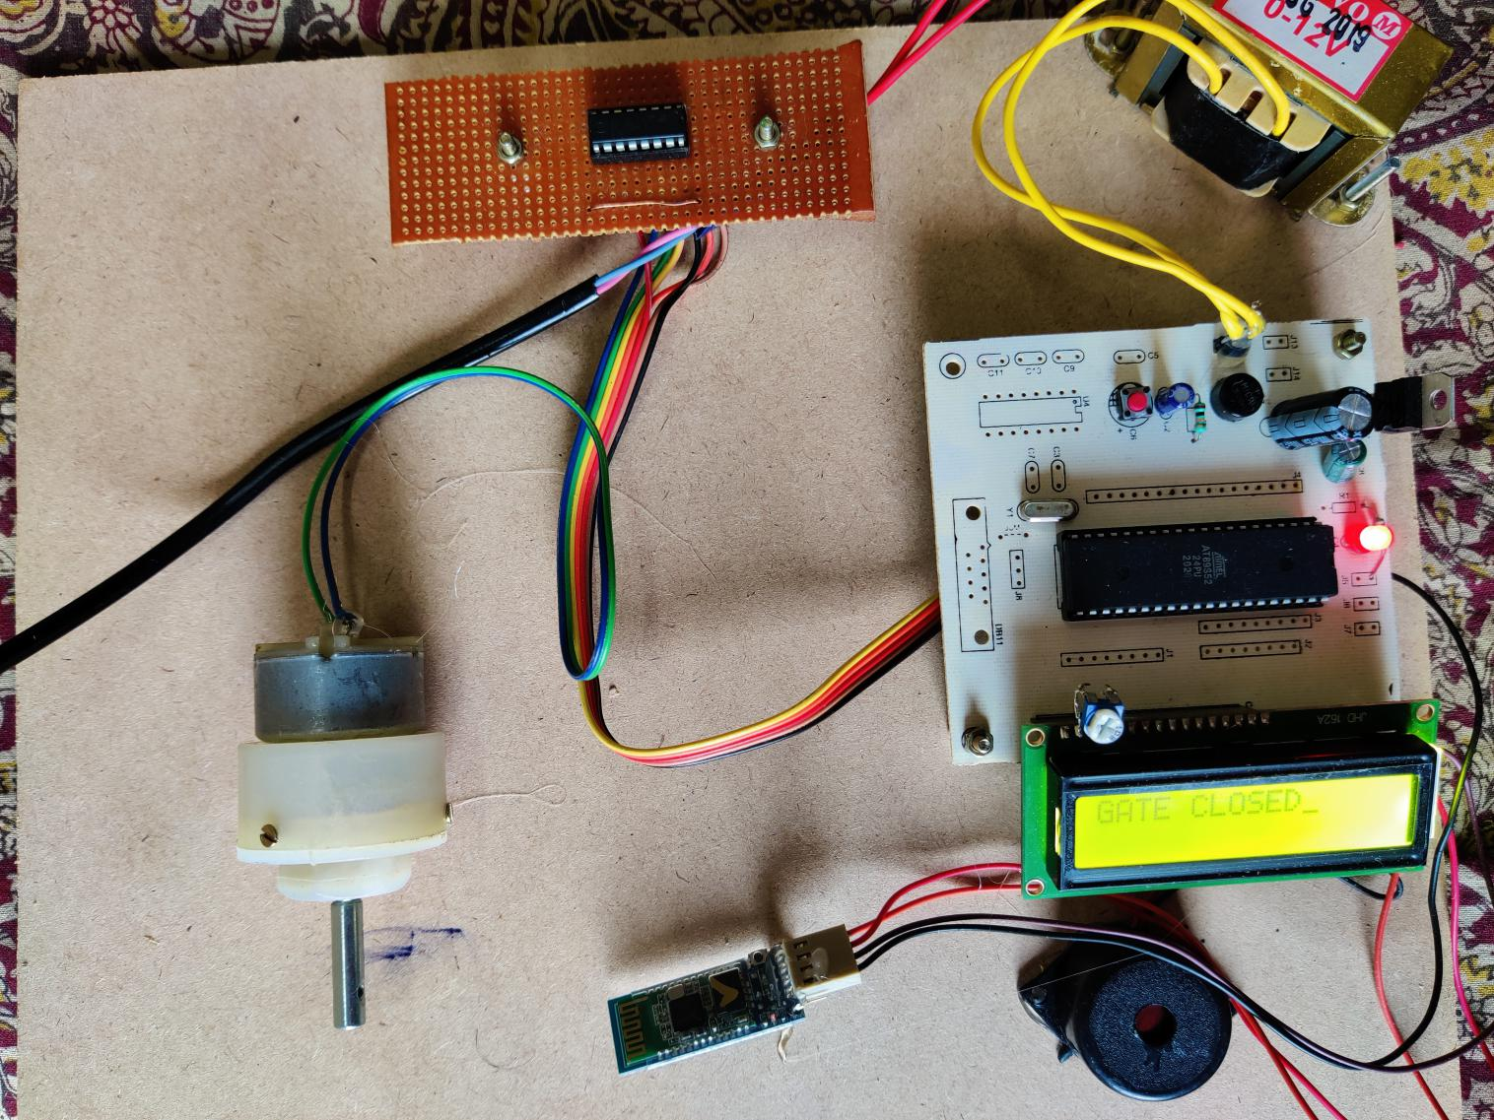

One of the outputs of this kit is displaying message on LCD screen and the other one is in the form of sound which comes from buzzer. After the input from the operator is obtained all the internal processes are carried out and the output is sent to LCD and buzzer.A predefined value is assigned for Gate Closing.The Bluetooth detects the input ASCII command “C” and diaplays the message “GATE CLOSED”.

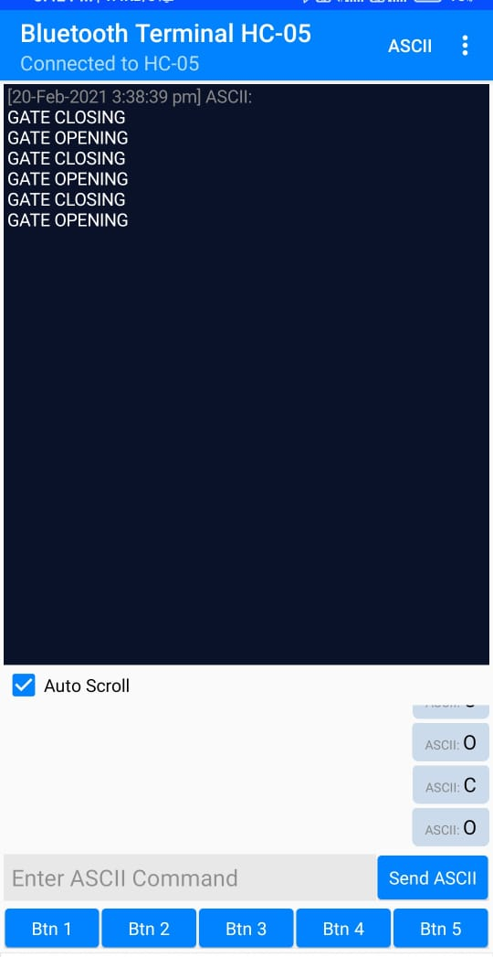

This figure shows the message sent to user on mobile through Bluetooth Terminal HC-05 Android Application .when the ASCII command “C” is send then gate is closing which displays message “GATE CLOSING” .If ASCII command “O” is send then gate will opening which displays message “GATE OPENING”.
CHAPTER 7
7.1 CONCLUSION:
From the above information of this system up to now, surely comes to know that it is highly reliable effective and economical at dense traffic area, sub urban area and the route where frequency of trains is more. As it saves some auxiliary structure as well as the expenditure on attendant it is more economical than traditional railway crossing gate system. We know that though it is very beneficial but it is also impossible to install such system at each and every place, but it gives certainly a considerable benefit to us, thereby to our nation.
7.2 FUTURE SCOPE:

CHAPTER 8
8.1 REFERENCES:
[1] en.wikipedia.org/wiki/Rail_inspection
[2] en.wikipedia.org/wiki/Nondestructive_testing
[3] en.wikipedia.org/wiki/Level_crossing
[4] en.wikipedia.org/wiki/Laser_scanning
[5] B. Brailson Mansingh, “Automation in unmanned railway level crossing”, in Intelligent Systems and Control (ISCO), pg. 1 – 4, 2015
[6] Onder Halis Bettemir, “Detection of railway track from image by heuristic method”, in Signal Processing and Communications Applications Conference (SIU), pg. 1366 – 1369, 2015
[7] Selvamraju Somalraju, Vigneshwar Murali, Gourav Saha, Dr.V.Vaidehi, “Robust Railway Crack Detection Scheme (RRCDS) Using LEDLDR Assembly,” in Networking, Sensing and Control, vol. 6, iss. 3, pg. 453-460 , May2012
[8] Qiao Jian-hua; Li Lin-sheng; Zhang Jing-gang; “Design of Rail Surface Crack- detecting System Based on Linear CCD Sensor,” IEEE Int.Conf. on Networking, Sensing and Control, vol. 14, no. 4, pp. 961-970, April 2008
[9] K. Vijayakumar, S.R. Wylie, J. D. Cullen, C.C. Wright, A.I. Shammaa, “ Non invasive rail track detection system using Microwave sensor,” Journal of App. Phy., vol. 9, iss. 11, pg. 1743-1749, June 2009
[10] Richard J. Greene, John R. Yates and Eann A. Patterson, “Crack detection in rail using infrared methods,” Opt. Eng. 46, 051013, May 2007
[11]. R.J. Greene, J.R. Yates, E.A. Patterson, “Rail Crack Detection: An Infrared Approach to In-service Track Monitoring,” SEM Annual Conference & Exposition on Experimental and Applied Mechanics, vol. 112, nos. 23, pp. 291301, May 2006
[12] Giovanni M. Carlomagno, Carosena Meola: HComparison between thermographic techniques for frescoes NDTH NDT & E International, Volume 35, Issue 8, December 2002, pg. 559-565.
[13] Hartless, P.C.M.; Whalley, D.C. Automated thermographic inspection of surface mount solder joints. Automotive Electronics, 1991., Eighth International Conference on Volume , Issue , 28-31 Oct 1991 Pg.178 – 181.
APPENDIX-B


NAME: CH K CHAITANYA
HT.NO:17831A0414
CONTACT NO:9948344091
E-MAIL:Chaitanya7c@gmail.com


NAME: K RAJA
HT.NO:17831A0435
CONTACT NO:9666800736
E-MAIL:maminiraja.0904@gmail.com


NAME: K SAITEJA
HT.NO:17831A0436
CONTACT NO:8977767167
E-MAIL:kanikesaiteja@gmail.com

